4,000 TIMES
He Has Dropped From The Clouds
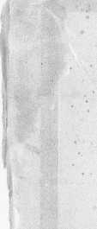
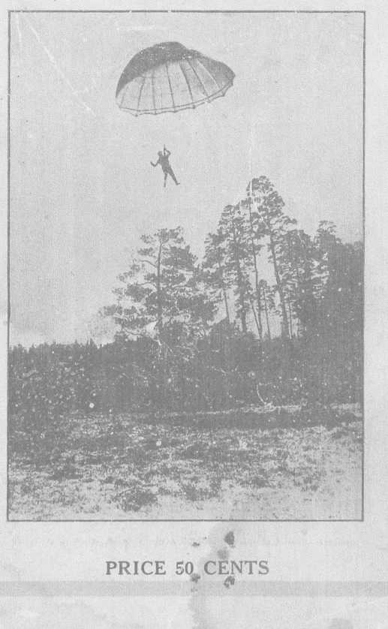

WHY THIS STORY?
The world today is interested in Aviation. I have probably answered more questions in the past thirty-five years, than the average man would in a long life-time. “What time does the balloon go up?” has been asked me thousands and thousands of times. A few years ago I carried a sign stating the time the ascension would be made. This sign was placed on the balloon lot, where everyone could read it, but most of them would walk past the sign, and ask me the old question.
There is a something in most of us that will impel us to want to just talk with, shake his hand, or get near to any man who risks his life the same as I have been doing for years. I always try to be courteous, for I know they will feel better after a few words with Bonette. I have been asked for a book of my life so often that I have decided to try to place one before the public.
Another frequent question is “How many times have you been up?”
I have always kept an accurate record of every ascension I have made, and in looking my books over, I find that I have made exactly four thousand, one hundred and sixty-one ascensions since I started my aerial career in 1892.
Have I a GOAL? Certainly I have; I intend to cross the 5,000 mark.
I have made nearly that number of parachute drops, for since I originated double and triple drops, I often make one or more drops, each time I go up.
The following stories taken from Boston papers, and one from the article that appeared in “Success Magazine” this last August, written by the noted author, George Allan England, will give my readers a pretty good idea of what I have gone through, since I started to fly thirty-five years ago.
I have few bones in my body, that have not been broken; and when I look back and realize what I have done, and
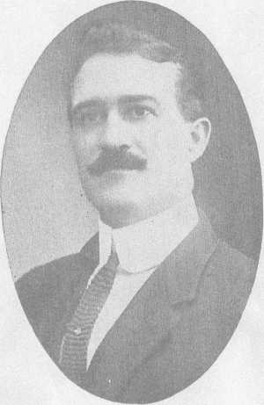

Prof. C. C. Bonette.
Born at iSt. Johnsbury, Vt., Oct. 24th, 1872
and holds the World’s record for
Parachute jumps.
the many narrow escapes I have had, I say to myself I am a very lucky man to be living. I am a fatalist, and this belief has kept me up. Another question is: “How do you feel when you are ’way up in the air?” I have tried to explain, but words can’t express the feeling one has. Afraid? No. If I was, I would not be up there? Of course one has a feeling that some old thing can happen, the balloon collapse, ropes get tangled up; cross winds may hit you. air-holes, and plenty of other things that could go wrong.
On September 10th, this year, 1. was making the balloon ascension at Worcester, Mass., for the Norton Company Picnic. We had a thirty-five-mile wind all day long, and could not inflate the balloon Until late in the afternoon. About five o’clock the wind died down, enough so we started the filling, as everyone had waited on the grounds to see the balloon rise, and 1 never disappoint an audience, if there is a possible chance to go up. I knew there were strong winds up there, but after fighting the ground winds, and getting the balloon inflated, I took a desperate chance and went up. When up a thousand feet, I struck a forty-mile-wind, that took me across the city in less than three minutes. I reached an altitude of thirty-eight hundred feet only, as a balloon can’t climb in such a wind as I encountered that day. The next thing was to get a lull in the wind, so I could get away with my parachute, but the lull did not come, and I had to do the most crazy thing I could do, cut away in this high wind, and trust to luck.
The wind held the parachute cloth together and it could not open. A man’s brain is quick at such times, and I did the only tiling I could do, to make it open. I jumped up through the parachute ring, grabbed hold of two sections of the parachute-ropes--one section in each hand—gave them a quick snap, and it opened up. But not until I had fallen more than five hundred feet, and every one on the ground came very near witnessing a fatality. Two of my brother friends, aeronauts, were killed that same day, on account of high winds. One was killed at Rutland; Ver-
mont Fair, the other one in New York State, and another could have been killed at Worcester, if I had not done just as I did do, in opening up my parachute. I landed nearly four miles from the picnic grounds, and was so weak that I could not stand on my feet. I felt the effects of that long drop, for many hours. But such experiences are part of this game; that is, if you want to keep up your reputation, and please the people and the Societies you are working for. The more chances you take, the more popular you become; but people on the ground never know what goes through a man’s head at such a time, when he is risking breaking his neck just to please them.
Another frequent question is: “What is the most dangerous part of flying?” I can truthfully say it is in landing back on the ground. Most of my accidents have happened when landing, coming down on tops of buildings, in trees, steeples, into rivers, oceans, and in fact ’most every conceivable place one can think of. The water is not so bad a place to land; the only bad thing about a wet landing is getting everything, including yourself, soaked, and it takes one long time to dry out a thousand yards of cloth, sewed up in a balloon. I have been nearly drowned two times, and I have a holy horror of big waters, for it is “Three times and out!” in some cases, and I honestly believe, I will kick off by drowning.
High tension wires are bad for any flyer. I have had some sad experience with them. Lost two balloons, that dropped on high tension, and have just missed landing on them numerous times, and by leaving the parachute on one occasion, falling forty feet and breaking all the bones in my right ankle.
Another question: “What does a balloon outfit cost?” I make all my own balloons, and parachutes. It takes from 800 to 1000 yards of unbleached muslin to make a balloon, and one hundred yards of percale cloth for a parachute. Then there are all the ropes, the heavy two-inch webbing

and other incidentals to be figured on. I can make a 75-foot balloon, well banded and corded, for less than $300 but it costs much more when bought from a balloon manufacturer. I sell new outfits complete for $500.
Some people have an idea that balloons are made out of silk. I have never seen a hot air balloon made with silk. Government parachutes are made with silk. I always use the strong percale, as it wears much longer than silk, and is just as good, I believe.
“How old are you, and how long have you been flying?” is often asked. I. was born October 24th, 1872, and have been flying for 35 years; was born in St. Johnsbury, Vermont, same State and same year as friend Coolidge. Vermont has turned out some mighty smart men, but I believe I am the only aeronaut born and raised in the Green Mountain State, so far. Before I was ten years old, I had made up my mind that I would be a balloonist. My folks had planned to have me study medicine, and become a doctor. I could not see it that way, but if I had ever known then, that I would spend so much of my time in hospitals, I believe I would rather have thought of being the doctor, instead of the patient. I was married when I was 24 years old, and to one of the best women on earth. Was married less than two years, when mv wife broke her back, in making a parachute landing at Malone, N. Y. Fair. She lived twenty-five years, in a wheel chair. I spent a fortune on her, but to no avail. She passed away five years ago; died as she had lived, with a smile to the last, and one woman without an enemy. To know her, was to love her.
I now have a home in Melvin Mills, N. H., near lake Sunapee, and spend lots of my time there, when not filling engagements, building new balloons, and keeping in good shape. The best part of my home is my gym, where I have all my riggings hung up, and where I am practicing up new stunts for the next season.

I am never alone, as there are so many who want to learn the aerial work, and I feel proud of some of the good acrobats I have taught in this same gym. After all is said and done, this is not such a bad old world after all, and when I do make my five thousandth ascension, I feel that I have done my part. Then I will come back to my little house and will “let George do it.”

THE THRILL-MAKER

How the Parachute-Jumper Flirts With Death, to Make Us

Gasp and Cheer.

FALLING for a living—that’s the parachute jumper’s job. A cyanide of potassium job it is, too, because one drop will kill you if it gets you just right. Some job!
Not everybody has the chance to study a parachute-jumper at close range. But that chance is mine, because the most famous veteran jumper in America and probably in the entire world just happens to live right in my own home town of Bradford, New Hampshire. So, off and on for some time—when he hasn’t been leaping from the clouds at country fairs and amusement parks—I’ve been hobnobbing with him. And here’s his story. The story of Professor C. C. Bonette, the only 'chute-jumper of long experience who still survives. Professor Bonette, king of aeronauts, mid-heaven artist extraordinary!
To begin with, Bonette has spent almost his entire life, risking it. He has been catapulting himself from the sky for over thirty-five years, and has thrilled more people, by way of amusement, than any other man alive. More than 4000 times he has played tag with Death, to make not a Roman but an American holiday; and he’s still hale and hearty, to tell you all about it and laugh. Though practically all the bones on his left side have been broken, some of them twice; though he’s cross-hatched all over with scars from gouges and lacerations; and though six times he’s been reported dead, this death-proof individual is still lively as a cricket and is still leaping from the blue.
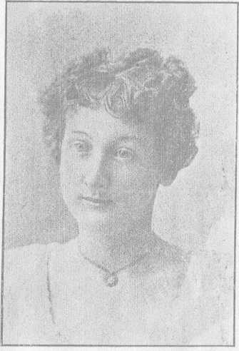

Mme. Minnie, wife of C. C. Bonette. Born in Brooklyn, N. Y., April 25th, 1875. Broke her back in making a parachute landing at Malone, N. Y., Sept. 27th, 1897; lived nearly 25 years in a wheel chair; passed away at Sutton, Vt., March 29th, 1922, and died as she had lived—with a smile on her lips. One woman without an enemy.
His specialty is soaring aloft and swooping down again while holding to balloon or parachute only by his teeth. They aren’t even his own teeth, either. They’re store-teeth, and have been for eleven years. I don’t know who made those teeth, but they’re good. So is Bonette’s nerve to trust his life, a mile up in the clouds, to a mere set of “uppers and unders”. As yet, they’ve never broken. If they ever do--but why borrow trouble?
Millions upon millions of awed spectators, in this country and many others, have cried: “Oh!” and “Ah!” as they have watched the Professor zoom earthward suspended only by his iron jaw and glittering, golden teeth. If you yourself have ever stood in a gaping crowd, with thrills of delicious trepidation in your heart and a crick in your neck, watching “Dare-Devil Dick’s Death-Defying Dive to Doom,” you probably have seen this conqueror of the skies.
And you may still see him again, more than once—if something doesn’t slip.

How It All Started
“Guess I bear what they call a charmed life,” the Professor confided to me the other day, with an aureate smile. This brown-eyed, alert and well-set-up man of steel nerve and of innumerable injuries was frying hamburg and onions in his little summer camp at Todd Pond, Bradford. In paint-blotched shirt and canvas trousers he looked like anything but a Dare-Devil of the Empyrean. “I was born to be an aeronaut. Took to it like a duck to water. Couldn’t help it any more than you can help writing pieces for the paper. That’s the way things are, in this funny old world.
“Yes, reckon I’m the oldest active airman alive. Fifty-four years old, that's me. Pretty ripe, to be still jumping from the clouds, eh? Most aeronauts quit by the time they’re forty—if they live that long, which most of ’em don’t. Ten or fifteen years of work usually finishes ’em, one way or another. Out of all that were working when I started, not one is still in the game. They’ve all quit or got theirs. The great Sam Baldwin himself, who trained me, said: ‘When I kick off, Clarence, you can wear the hat.’ Baldwin was killed in air-work, years ago, and both his brothers are gone, too. So I guess the hat is mine, all right enough.
“I always had the show bug, from the farthest back I can remember as a kid in St. Johnsbury, Vermont. That’s where I was born and lived till I was about nineteen. Father had a farm there, but farming never looked good to me. His barn looked good, though, because it was just the place to rig up a gym. It’s a miracle I didn’t break my neck a hundred times, out in that old barn. The homemade gym kept me pretty contented till I was about eight. Then a circus came to town, and that finished me as a young farmer. The high-wire and balancing stuff caught me, hard. Tight-rope and trapeze artists became my gods, and from then on it was the show-business or nothing, for me.
“You’d be surprised,” the Professor continued as he turned his hamburg, while Larry Saunders—his present apprentice—looked on with interest, “you’d be surprised the havoc I made with my mother’s clothes-line from then on. I was always rigging up tight-ropes and trapeze-bars. If I fell off once, bet I fell off a thousand times, but the hardest wallops only made me more determined to go
higher and fall even harder. Any day when I wasn’t black and blue was a rarity. For that matter, I’ve been black and blue on some part or other of my carcass pretty nigh ever since. That’s all in the day’s work when you're a balloon-jumper.”
Bonette’s lively eyes sparkled and his soldier-like chest came out as he straightened up from the stove. Soldier-like is the word. His bearing is military, athletic, alert; and though he limps perceptibly from an ankle broken twice by falls about which we shall hear later, his every motion is agile, sure and strong. Powerful nerves and complete muscular control seem to explain the fact that he has succeeded in pulling the very whiskers of Death for more than three and a half decades and still lives to tell you how it's done.
“My first parachute-jump was when I was fifteen," he went on, fork in hand. “I did a Darius Green with an umbrella out of an upper barn door. I took off, all right enough, but the umbrella turned inside out and I landed on the old bean. If there hadn’t been a pile of straw handy, guess I’d have ended my career right on the spot. The fall didn’t hurt me much, but father’s paddle did. So I got some black and blue spots even that time, too. It was father’s best Sunday-go-to-meeting umbrella, you see.
“I kept right on, though, with my stunts. By seventeen, I was really expert on the slack and high wire. Then one day about two years later my big chance came, as it comes to everybody if they only know when to grab it. I was at a fair in Plymouth, N. H., in 1893, where they’d billed an ascent and a jump. But the aeronaut had got injured some way, and couldn’t go up. So I volunteered. What?
Of course not! I didn’t know beans about air-work— didn’t know any more than you do, this very minute. But I went, just the same.
“McEwen, the man in charge, strapped me in like any amateur. I’ll never forget the feeling when I first soared aloft. Fine? Oh, wonderful! I knew that was the life for me, oh, boy! When I was about half a mile up, McEwen fired a pistol for me to cut loose, but I saw the Pemigewasset River right under me and figured I’d drop into it, so I hung on.
“Nowadays I know how to calculate my drop, by calculating altitude, cross-country speed and probable distance the ’chute will fall before opening. I can usually hit the ground pretty close to where I want to—usually, though not always, which is why I’m lame today. But then I didn’t know anything; just thought I’d fall vertically. So I stuck to the balloon till it was nearly a mile high before I cut. And when I came down, the river was more than a mile away.
“Did my first jump scare me? It sure did! I was scared stiff, all right. And so was McEwen. He called me everything he could think of, and then some. He thought I’d be killed, and no two ways about it. The first time you jump off a balloon, from up in the clouds, it certainly does frighten you.”
“Yes,” I agreed, “it must. I’ve promised myself never to try it except on my one really lucky day, the 29th of February.”
“Good idea,” the Professor approved, from his cookstove, “if you haven’t got the real instinct for it. Any man that says he wasn’t scared the first time, is lying. But
Showing different stunts in the air with
Parachute.
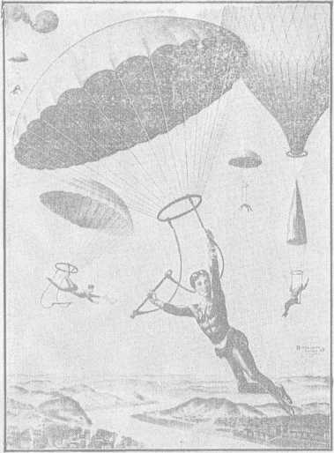

it’s the very fear of the game that makes it a good one. Not much competition, you see. The trouble with most good jobs is that somebody’s always trying to get 'em away from you. Just the minute you get nicely fixed, some fellow comes along and tries to be your understudy. But in the balloon-jumping game there aren’t many applicants.
“What worried me most, that first time when I jumped from a mile high, was whether the ’chute was going to open or not, and whether—if it did open—it would act like dad’s best umbrella. But everything was all right, and on the way down I got up nerve enough to take off my belt and even do some trapeze stunts, another reason why McEwen gave me Hail Columbia. Come on, let’s have a bite o’ grub, and then I’ll tell you some more about the greatest game on earth—which is leaving it and then jumping back again!”

So Many Things May Happen
During the bite o’ grub, I took stock of the very interesting lay-out the Professor’s cottage holds. In one corner lay a great mass of red, white and blue percale with many ropes attached; a parachute that he was making ready for his next engagement extraordinary. On a nail hung a stout, scissors-like affair, or perhaps it may better be described as a kind of gigantic cigar-cutter. This contraption is of tempered steel and has a keen knife-blade so arranged that when a rope is pulled the blade will cut another rope passing through a hole. And from a beam suspended a peculiar leather device shaped something like a set of teeth. Beside the stove, also, stood a pair of crutches that showed signs of long, hard use.

The crutches were self-explanatory, but the scissors- knife affair needs a little exposition. The Professor invented this dingus, himself.
“But it’s not patented,” says he, “because there’s no general demand for such an article. That’s the best of this game—an expert has it all to himself.”
The dingus in question is the knife he uses for cutting away from his balloon when in the airy blue. It holds the top of the parachute to the bottom of the balloon, from which a rope hangs down through the ’chute. A pull on this rope cuts the connection, and down the ’chute goes plunging. The Professor always gives his knife a very painstaking examination the last thing before he goes up. If it should clog or jam, he’d have to stay with the balloon and maybe travel many miles, coming down Lord knows where or how.
As for the leather device, that is the mouthpiece by which he hangs suspended. Need one say he looks that over, too, with the greatest care?
“The least little thing that goes wrong might spell my finish,” he explained between bites of hamburg, which he attacked with the same glittering teeth that have so often held him suspended in mid-sky. “There’s always lots of things can go wrong, in this business. And if anything happens, you probably never have a chance to try again and do better.
“Most of the accidents in ’chute-jumping are caused by some neglect or oversight,” continued this greatest of all thrill-producers. “Pride goeth before a fall—that’s a good one to remember. You must never be too proud to look everything all over before you go up. Otherwise you may

be facing certain death. Twisted or knotted ropes will make the ’chute open up lopsided, and then it’s all over but the slow music and the flowers.
“I watch all details, no matter how small, from the time the inflating-trench is started till the bag and ’chute are folded up for the night. Certain things, of course, I have to leave to my assistant, but I take mighty good care in picking the assistant. One thing, for instance, that I have to trust him with is making sure the balloon isn’t afire before I go up.”
“Yes, that might be inconvenient,” I remarked. “A trip in a blazing balloon wouldn’t make a man exactly a first-class insurance risk.”
“You’re shouting, it wouldn’t!” the Professor earnestly agreed. “Yet that’s an easy accident to happen. I use hot-air balloons, of course. They’re filled from a fire, through a trench some twenty feet long and about two and a half deep, ending in a vertical stack maybe four feet high. That’s a quick method. I can fill even a ninety-foot balloon, holding forty thousand cubic feet of hot air, in eight or ten minutes.
“As the balloon fills, it’s held up by two forty-foot poles and kept captive by twenty-four sand-bags and by about fifty men holding ropes. When it’s full and the ’chute tied in place, I always say: ‘Charlie, put the cover on!’ and then I go. I always call my assistant 'Charlie’. Just a little habit of mine. ‘Put the cover on’ means cover the stack.
“Poor Charlie, whoever he may be, has about the worst job in the world. He has to stay inside the balloon while it’s being filled, to keep sparks from setting it afire. Were
you ever inside a hot-air balloon while it was filling?”
I modestly disclaimed any such experience, and indicated a certain reluctance about trying.
“Don’t blame you a bit!” the Professor affirmed. It’s hell that’s what it is. I’d rather make a dozen jumps than go inside a filling balloon just once! Yet somebody has to do it, to make sure no sparks catch the cloth. Suppose the balloon was to get afire just as I was leaving the ground!”
“I’m supposing. Go right ahead!”
“Well, the minute I got up, the breeze would fan that fire into a great blaze. There’d be mighty small chance the bag would rise high enough for me to cut away and make a safe landing. And if it came down on me, all afire—”
“Quite so, Professor. How high do you have to be, before you can drop?”
“Well, the ’chute usually falls plumb for two or three hundred feet before it opens out at all. I’ve even known it to drop five hundred, but that’s very unusual. Anyhow after it opens, for the next two hundred feet or so it’s swooping down at such a clip that if you struck then, you’d have to be picked up with tongs. So five or six hundred feet is about the minimum height it’s healthy to cut away from—say as high as the Washington Monument.”
“A mere trifle,” said I. “Ever burn up a balloon?”
“Oh yes, three of ’em,” the Professor smiled. “But that was in my early days when 1 thought I knew it all, which I don’t now. I was lucky, though, and didn’t happen to be in the air with any of ’em.”
“And what’s your maximum height?”
A four-minute teeth-stunt.

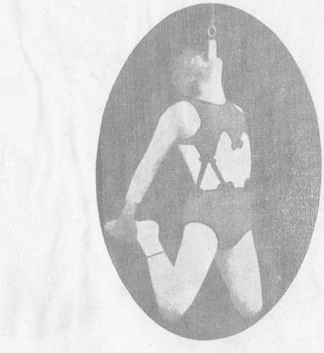

“Oh, I usually drop anywhere from four to seven thousand feet, though I’ve registered seventy-two hundred. That’s nearly a mile and a half.”
“Must feel fine to jump a mile and a half!”
“Kind of a ticklish feeling,” Bonette explained. "You know, like starting down in a swift elevator. But if you've got your ’chute and ropes properly folded and coiled, you know the 'chute has simply got to open. So you're safe enough—as far as falling is concerned. Landing, of course, that’s a different matter. There’s a certain amount of luck in that.
“And speaking of luck, I’ve been mighty lucky in one way. I’ve never killed a man working with me. It's true my wife was fatally injured in a ’chute-drop,” and Professor’s face darkened. “But that was from a separate balloon. I’ll tell you about that, later. The worst accident I ever had happen to a man on my own balloon was out in Springfield, Vt.”
“As per how?”
“One of the men holding the balloon got confused, and when I shouted: ‘Let her go!’ he stepped forward instead of back, as everybody’s always instructed to do. A rope caught him round the leg, and he went up, head down."
“Agreeable situation!”
“Sure was! But he kicked clear, before we were very high. He wasn’t in the hospital but a few days. I never hurt anybody in the crowd or anywhere, falling on 'em. Used to have the balloon all roped off, but the public's better educated now and knows enough to keep back. Anyhow, I always have police protection, at least four cops, to keep ’em away. That’s all in the contract, police pro-
tection is, and the same with damages. I’m not responsible for busting in buildings or chimneys or the like o’ that. Always hate to do damage though, to anybody or anything.”
“How about yourself, Professor?”
“Oh, I don’t like that any more than you would, yourself,” answered Bonette with a sparkle of his big brown eyes, always so keenly alive. “But if it comes, it’s all part of my job. And as for getting killed, I never even give it a thought. I’m a fatalist, you see. I figure this way--if every hair in a man’s head is numbered, why shouldn’t his days be, too?”
“That’s right,” I admitted. “They should.’’
“Well then,” the Professor argued, still busy with the hamburg and fried potatoes, “when you’re born, the time of your death is all set. Nothing you can do or not do will change it by a single minute. So when it’s my time to go, I’ve got to go, even if I’m right down here on terra firma. ’Chute-jumping can’t finish me, not even a second sooner!”
“That,” I remarked, “is a mighty comforting conviction for a man in your line.”

Mortality One Hundred Per Cent
“Comforting, yes, it sure is. I don’t see how anybody that isn’t a fatalist can be a balloon-jumper at all. Because, you see, everybody that follows it long enough always gets killed at it, same as deep-sea divers, oil-well shooters and so on. Yes, sir, they always either quit or get theirs. I’ve seen lots of ’em go. Not one of all the men and women prominent in the game twenty or thirty years ago is now active or living, except me.
“There was Sam Baldwin, the old-time champion. He got killed in a drop, out West. His brother Ed, ditto, before I was with the Baldwins at all. Tom Baldwin retired before it got him, and died in his bed about three years ago.
“The Baldwins, you know, were the first to ever introduce ’chute-jumping into the United States. And speaking of the Baldwins,” he continued, pushing back his plate, “I did my first professional work with them. Sam was then America’s most daring balloonist and jumper. After I’d had my baptism, so to speak, in an amateur way, I wrote him out in Chicago. He told me to come out and join, which you bet I was mighty glad to do. He trained me so I made my first real ascension and drop when I only nineteen, in Sturgis, Mich. Since then, of course, I’ve worked all over this country and much of Europe and other places. Sam Baldwin taught me a lot. A fine, fearless man he was, too. I only wish he’d quit sooner!
“Then there was Walcott. Lots of Americans must remember him,” the Professor went on, stroking back his crisp hair from a thoughtful forehead. His strong features, interestingly wrinkled by many adventures, grew sober. “Walcott eventually died from injuries he got in South America. For years, though, he went on crutches and superintended other jumpers from a buggy he rode round in. McBride’s parachute failed to open at Lynn, Mass., in 1912, and every bone in his body was broken. Barr was killed by falling into the ocean, at Nahant.
Carrie Meyers—a good one, for a lady jumper—met her death in New York State. The famous Mrs. Vincent came to her end while working in Houston, Texas. Three of my own partners, beside my wife, were killed. The

first was Joe Florentine, who got dropped out in Michigan--but not while working with me. Jack Sawyer, and then Frank McBride both got theirs, but the same as Florentine, not with me. Point of Pines, Mass., finished them. Sawyer fell on a railroad trestle—mighty bad case. Three of my partners are still alive, Dan Friend and Louis King, both retired; and Allen Gay who’s still working with me, but plans to go out soon. My partners and I always work as Bonette Brothers, though I’m really the only Bonette now in the game.
“My wife’s case was mighty bad. A fine jumper, she was! Did all kinds of daring stunts and never knew the meaning of fear—one of the greatest aeronauts the world has ever known. She liked double jumps, though I was always against ’em—that is, both of us going up in one balloon, with two ’chutes. One day in 1897 at Malone, N. Y., she was making a single jump when a sudden gust of wind caught her just as she was almost down. It threw her against some high telephone-wires. She grabbed a wire but couldn’t hold on—the wind was blowing too hard—and fell right on a hard road. That broke her back. She lived about twenty-five years in the greatest suffering. A helpless cripple, in a wheel-chair. Sometimes she’d sit in that chair and watch me jump or do my whirling slide for life. Never complained at all. I tried every specialist I could get hold of, but none of ’em could do a thing for her. That’s one reason why I’ve stayed with the game so long. Had to have money, and lots of it, for that brave little woman. She died only about three years ago, helpless to the end. A fine, courageous little wife she was, too—the best that ever was!

“Yes, sir, ’chute-jumping gets ’em all, in time. It's a 100 per cent mortality game, if you stick. But my time hasn’t come yet, so I’m safe. Though if you wanted to make a date with me for next week or next month, I couldn’t be sure of keeping it. I might be here, all right, and then again—somewhere else. Who knows?
“Funny thing about the attitude of the public. What really pulls the crowd, of course, and makes ’em swarm to every balloon-ascension, is always the secret hope the aeronaut will get badly hurt or killed. Everybody denies it, naturally, but it’s so just the same. It’s exactly like the wild-animal acts where the trainer may get his head snapped off. What makes my act popular is the chance I’ll never finish it. And when I do, and when I’ve disappointed all those people by not obligingly getting killed, lots of 'em will say—'What a damn fool to take chances like that!' Human nature is sure peculiar, and never more so than at the fair-grounds while a balloon act is on.
“Queer, but people are a lot different in a theatre. I’m in vaudeville, winters, with a partner. We do comedy trapeze and wire work. There’s been a great change in that, since I began. It’s not nearly so dangerous to please the indoor public as it used to be. Nowadays, I can risk my life a dozen times a performance, and the audience will sit and yawn. But the minute I start a little easy comedy trapeze or wire stuff, I get ’em going right away. Only, I have to change the comedy every year. No second-year stuff gets over. Human beings are funny, all around. Nothing but just big, grown-up boys and girls, that’s all.
“But come on outside, and I’ll show you one of my ’chutes, so you can see what kind of a thing it is I trust my life to, when I jump from the clouds hanging by my teeth.”

He Makes Them All Himself
Professor Bonette hauled the great mass of red, white and blue cloth from its corner, and dragged it out into the field that stretches from his cottage down to the wooded shores of Todd Pond. The nice little breeze that had been blowing promptly died down, as breezes always do when you want to fly a kite or blow up a parachute.
“But there’s one sure way to make a wind blow,” smiled the Professor with a glitter of gold teeth. “Just start your fire to fill your balloon, and you’re sure to get a breeze--when you don’t want it. I’ve almost never known it to fail.”
As he unfolded his parachute, with the help of Larry Saunders and his curly black Cuban spaniel, “Peggy”— the only dog of her kind, by the way, in the United States--he talked of various matters. One thing was about “Tricky”, the little dog that used to make many a jump with him, and like them, till the Society with the Long Name stopped it. Another was the construction of his apparatus. He makes all his own, does the Professor. Never does he trust any hand less skilled than his own, in this vital work.
He uses, it seems, the largest balloons and the smallest ’chutes of any one in the profession. His balloons are usually sixty feet in diameter and seventy-two feet high, though some run to ninety. He cuts them out of unbleached muslin, in forty-six segments, each segment seventy-two inches wide at the middle.
During slack seasons he cuts them out in his brother’s immense barn, at Waterford, Vermont, using no pattern at all except the one that long experience has taught him to carry in his brain. He sews the segments in pairs, at
first, and then joins all the pairs to make the finished balloon. Each balloon is lined with another thickness of muslin, fifteen feet down from the top, and is provided with five transverse bands of stout webbing to keep the cloth from tearing.
A strong bottom-rope, and a hand-hold rope four feet from the bottom complete the great hot-air bag, which may cost anywhere from $300 to $450. Bonette always has two ready for every performance, so that in case one burns up—and he escapes alive—he can use the second. Foresighted Professor!
As for the 'chutes, he sometimes cuts them out of red, white and blue cloth, sometimes out of white and green. They weigh about thirty pounds, have an air-hole at the top, and are provided with thirty or forty stout cords sewn into the seams all the way from top to bottom. These cords continue downward to a ring, whence the trapeze is suspended.
The cut-away knife and the mouthpiece we have already seen.
“Just try to jerk the mouthpiece out of my teeth," the Professor invited, and I tried. But one might as well undertake to get a gunnysack away from a bulldog. That iron-and-gold jaw, once set on the stout leather, holds a death-grip that nothing can loosen.
“I held the world’s record for muscle endurance and jaw strength at the Olympic Games held at the Crystal Palace, London, in 1900,” Bonette explained. “Hung by my teeth —they were all my own, those days—four minutes and forty seconds. That was the time I did a special drop for King Edward. I’ve dropped for, even though not on, sev-

eral crowned heads. I’ve worked in France, at the big Exposition, and in Germany, Cuba, South America and many other foreign places.
“The Europeans are mighty critical about ’chute-jumping. That game started over there, you know. Oh yes, I like foreign work, though it’s sometimes hard to make the crowds understand you. One thing you’ll notice abroad--they demand greater risks to thrill ’em, than Americans do. You wouldn’t think it, but it’s so.”
Bonette’s foreign experience was somewhat responsible for his having introduced sensational features till then unknown in the game, so that now American stunts lead the world. Like his apparatus, he makes up his own feats. Long before he went overseas he invented refinements of daring that made the older generation of aeronauts gasp.
Not content with the ordinary ways of risking his life, before he was twenty he put on the first double parachute-act ever seen. Wiser heads solemnly shook, in direful warning.
“You’d better leave that stuff alone,” said they, “or you’ll surely break your fool neck!”
But after practicing with a small ’chute, he packed two of his inventions in a suit-case and pulled off the new stunt in Plattsburg, N. Y. It proved such a sensational success that the wiser heads, themselves, had to begin making double jumps. So Bonette started triples. He also originated the whirling “Slide for life” act, with a steel cable 500 to 1000 feet long. Up this he is pulled, hanging by his teeth or by one leg, and swoops down amid fireworks, landing in a net or a fountain while everybody hollers. Surely, one time or another, you must have seen him careening
Taken in Paris, France, 1900.

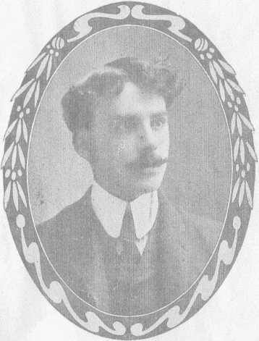

madly downward in the midst of flame and smoke?
Double and triple jumps, and fire drops, are no pastimes for a nervous man. In the doubles and triples, Bonette has two or three ’chutes. Hanging by his teeth he soars aloft, till he becomes a mere speck in the dizzy blue. Up, up, up he goes, with his arms folded behind him or else outspread, in proof that his teeth alone are holding him. His feet meantime execute a kind of dance, in defiance of Oscar Wilde’s dictum that—
“It is not sweet with nimble feet
To dance upon the air!”
Now he raises his hand and takes hold of the little trapeze just within reach. A nice, tidy place to faint, that would be! He swings up on the trapeze and does a few “ground and lofty” turns—all “lofty”, in this case. Onward and upward he goes. At five or six thousand feet he cuts loose, and drops like a plummet till the 'chute steadies. Then he cuts loose the second ’chute, which opens out of the first. Another sickening drop. A third presently follows. He ends up by taking the leather in his teeth again, and comes to earth dangling thereby, just as he went up. Thrills enough, and plenty!
Stunts of this kind have made Bonette the popular idol of country fairs and amusement parks. The crowd always cries for more of this sort—for does not the delightful possibility always exist that the gold teeth may break, and the Professor be “dashed to bits in the area,” like the infant of “Ruthless Rhymes” fame?
Even more delightful is the smoke-and-fire drop, in which an exploding bomb releases the ’chute. As it falls, ten bomb-rockets attached to the parachute-ring go off,

making a monstrous black cloud; likewise a lot of fireworks begin to shoot—red flares, set pieces, fountains and Roman candles—so that the Professor drops through a whirlwind of smoke and blazing coruscations. This act always makes men’s hair stand up, if they have any left, and is especially popular at night.
"It’s far ahead of the old-fashioned cannon-ascension,” Bonette says. "I invented it, and I’m the only one that puts it on. The chance of my being burned to a crisp, in mid-heaven, never fails to get the crowd worked up to the highest pitch of enthusiasm.”

Haps and Mishaps
It isn’t the going up that ever kills balloon-jumpers. It’s the coming down. You never know, when you soar into the empyrean, just where or how you’re going to land— which always makes it entertaining and prevents ennui.
"No fear of the work getting monotonous, none whatever!” said the Professor. "My ascensions this year are just as interesting to me as they were twenty or thirty years ago. No matter how much care we jumpers take in all our preparations,” he added, after an accommodating breeze had opened his ’chute in the field so it could be photographed partly in action, "there’s always things we have to take a chance on. I, for one, never know when there’s going to be a slip ’twixt the gum and the lip, as the poet says.
"The wind is our particular bugaboo. We’re always liable to drop into a pocket of ‘dead’ air that will let us fall hundreds of feet with practically no resistance at all. And once we get aloft, we’re likely to find the wind blow-

ing some other way than the one we reckoned on.
“I may start up with a fine east wind, for instance, and then after I get up a few thousand feet into the ozone run into half a gale from the westward. That sort of thing has made me land, no end of times, in water or forests or the middle of cities, when I’d calculated on a nice easy drop in open country.
“While the crowd of human ants, a mile or more below, is wondering whether I’ll be horribly mangled or killed--and I reckon half-hoping I will be—I’m trying to figure out what new conditions I face and how I’m going to land. Though you can guide your ’chute a little, you've practically got to go where it carries you. And that means you often run into some queer situations. When you come down a-straddle the ridgepole of a house, or hanging to the limb of a high tree, or sitting across some telegraph-wires, it’s sometimes mighty funny.”
“It must be,” I agreed. “I’d laugh myself half to death, if it ever happened to me!”
“Not always, though,” judged the Professor, "Sometimes you think you're a gone gosling, sure enough. I'm limping, today, on account of a shift of wind. The 10th of last July I did a drop at Spring Valley, N. Y. Up 5000 feet, I didn’t see some high-tension electric wires waiting for me. To dodge ’em, I had to let go my ’chute. Fell forty feet and broke my right ankle—the same one I'd already broken in September, 1925, out in Breckenridge, Texas, when I got carried against an oil well derrick. Derricks and chimneys are bad, especially factory chimneys. One of the worst jams was some years ago at Glen’s Falls, New York. I was making a splendid jump,

and an immense crowd was waiting for me to land on the Fair grounds, but a cross current drove me directly over the heart of the city, and as I swooped past the top of a church spire, the tape on the edge of my parachute caught on the weather vane and I brought up with a jerk, and there I was hanging without a chance to get hold of anything. My weight and the parachute came to over two hundred pounds, and all dangling by one narrow strip of tape. If that broke, well, the next stop was the granite steps of the church, one hundred feet below. I didn’t dare to make the slightest move for fear I’d break that tape. A huge crowd gathered, horror stricken. Women fainted, men yelled, and everybody expected to see Bonette’s career ended, somebody turned in an alarm and the fire department came on the run. They put up ladders and rigged a rope from the steeple. I went down, hand under hand. You bet, solid earth never felt better than it did that time!
“I once had my left shoulder broken, in Lynn, when my 'chute was blown against the side of a house. Another time, at Salem I landed on the very outermost branch of an elm, more than forty-five feet from the ground. The branch would have held me, alone, but when the ’chute came down on it, the limb broke. And the ’chute covered my head so I couldn’t possibly save myself. Next thing I knew, I had crashed, and five ribs on my left side were caved in.
“Pretty nearly the same thing happened to me once in Sydney, Cape Breton, resulting in a sixty-foot-fall and a broken left knee and hip. And one time in Bangor, I broke bones in my left wrist and ankle by falling against
Bonette in his famous Fire Slide for Life act. The smoke used in this act makes this picture looked blurred.
The public demands this kind of
stunts, and we try to please
the public.
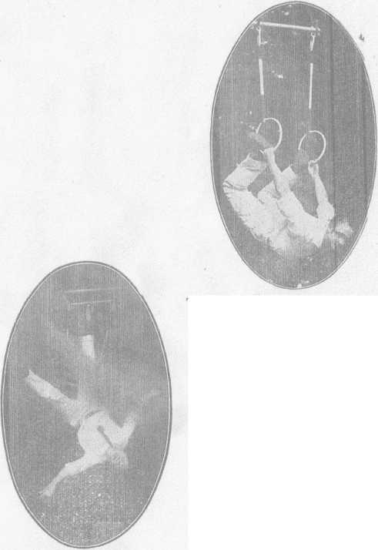

the side of a building. So as you see, nearly every bone on my left side has been smashed at least once."
“When you’re skyhooking down, swinging by those gold teeth,” I suggested, “it must be pretty hard to see just where you’re going to land.”
“It is,” Bonette agreed. “But it would be harder on me if they slipped or broke. However, that hasn’t happened yet.”
“And when it does?”
“We won’t talk about that. Why worry?”
“Ever do any airplane work?”
“Oh, yes. And I’ve made five long voyages in balloons, too. But that sort of thing is too tame for me. Nothing exciting about airplanes. It’s like eating pie, to jump from ’em. I’m the first man in the East that ever did that stunt. It was with McGee, at Rocky Point, Providence, somewhere about 1913. It’s too easy to be worthwhile. I like something with a real kick to it.
“What happened to me in Vandergrift, Pa., one time, had kick enough, and then some! It all happened on ac- count of a dead-air pocket. There’s mountains all round the place, you see, and every balloonist knows what that means—pockets. Well, the week I was showing there, everything went fine for twelve jumps. Park work, you know; that means fourteen jumps a week. My thirteenth jump was Saturday afternoon. It nearly put me out, for the count!”
“What happened?”
“Lots! I struck a pocket, dropped like a stone and struck a shed with such force that I crashed right through the roof. That roof was covered with slate shingles, mis- ter, and you’d be surprised what those jagged pieces of broken slate did to me on the way through ’em.

“They tore every stitch of costume from me, and cut me to ribbons, just like so many knives. I fell to the shed floor, bleeding from more than fifty gashes. Of course a big crowd gathered, and could I get out of the shed, dressed only in my birthday suit? I could not! I had to wait right there in seclusion, as you might say, till my auto arrived. That’s what you’d call going home in a barrel. No more Vandergrift for mine!

More Smash-Ups
Singularly enough, Bonette’s most perilous feat of all has never injured him. But then, if this had slipped at all, he’d never be here to tell about it. I mean his flying-trapeze stunt. This is a good thing for people with weak nerves to let alone. It makes you rather sweat, even to think about it!
The Professor works this stunt with a partner, each having a trapeze. The partner’s trapeze is slung under the balloon, and the Professor’s at one side of the big hot-air bag. When sailing somewhere among the clouds, Bonette stops hanging by his teeth or his toes and doing other gymnastic feats. He gauges his distance and makes a leap through empty air to his partner’s trapeze. He catches it on the fly, and they both come down together. Just a fraction of a second’s miscalculation, and—
“But as I was saying,” the Professor continued, “death is about the only thing I’ve escaped, so far. In addition to all the scars, smashed noses and broken bones, I’ve even had my big right toe nearly cut off by falling through a skylight. That toe is useless now; I can’t wiggle it any more. The total time I’ve spent in hospitals all over the
country would amount to many months. I’ve even been reported dead, six or seven times. Such rumors start after some accident when the doctors give out the statement that there’s absolutely no hope for me.
“One of my commonest experiences is to meet somebody who exclaims:
“‘Hello, Professor! Is that you? Why, my Lord, I heard you were killed last year’!”
“‘No, they only tried to kill me,’ I always tell ’em. 'It's
like what Mark Twain said—the accounts of my death haw been very much exaggerated!’
“I had a close call in Bangor, back in 1897, doing a sensational disrobing act as I fell hanging by the teeth. The wind drove me right down on the masts of a schooner moored in Penobscot River. By hard work I juggled the ’chute so that it missed the schooner, and fell into the river just under the bows of a steamer under full way! That was thrill enough for anybody!”
“How I envy you that experience!” I murmured.
“When you hit the water,” Bonette explained, “always let go the ’chute. It’ll blow away and clear you. If you hang on, it’s likely to come down on top of you and drown you. Always remember that.”
“I certainly will—when it happens to me!”
“And two years before that,” the Professor continued, “I fell into the ocean, after a jump at Salem, Mass. Came mighty near drowning, that time, but they fished me out just at the last gasp. When I first began my double jumps, both Baldwin and Walcott warned me I’d break my fool neck—but they’ve both been wrong, so far. In those days I used to go up hanging by my feet, with a knife in my
pocket to cut loose with. One time the knife fell out, and I had to come down with the balloon—always a mighty risky thing. I guess it was that accident that led me to invent my cut-away knife and take to the safer method of tooth-hanging.”
“What happens to the balloons, after you leave ’em?” I asked.
“Oh, they’re so made that they turn right inside-out, after my weight is off ’em, and come down at once. I almost always recover ’em. When you figure it takes me ten days to make a big bag and uses up eleven hundred yards of linen, you can see I don’t want to lose one.
“But speaking about ‘flops’, one time at Concord, N. H., I didn’t tie my ropes just right, and the ’chute came down sideways. Teddy Roosevelt happened to be in the crowd. He thought that crazy kind of a drop was a special feature, put on for his particular benefit, and gave me a great hand. I never told him it was an accident that almost cost me my life. Scared? You bet I was scared, for once, anyhow!
“There’s always a big crowd runs to the place where a ’chute-jumper lands—always kind of hoping, I reckon, they’ll find him mangled or dead. People get mighty excited, such times. In the old days when my wife was jumping, no end of women tried to kiss her after she landed. Oh no, they don’t try to kiss me—not twice, anyhow. But I’ll tell you what people always want to do, and that’s see my teeth.
“They always want to know what kind of teeth I’ve got, to hold me in mid-air a mile or more up. No trouble at all to show ’em, from any angle. Many a time I’ve taken ’em out and passed ’em around, to satisfy the public!
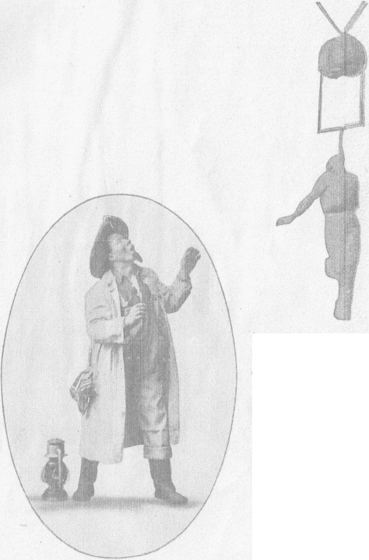

Leaving the ground hanging by teeth, with a packed parachute.
Bonette, in vaudeville, as The Vermont Farmer.
“It’s funny how practically all my smashes have been on my left side. The only accident I ever had happen to my right was at St. John, N. B., in the fall of 1922. 'Fall' of 1922 is correct. In that fall, my ’chute blew against the upper works of a ship in the harbor. As my ropes tangled in the topmast, I grabbed a crosstree. The suddenness of my stop tore the tendons of my upper arm. I haven’t wholly got over that injury yet, for torn tendons heal much slower than broken bones.

“Oh, What a Fall Was There, My Countrymen !"
“1 guess, though.” the Professor added, as he began folding up his parachute once more, “I guess the closest shave I ever had was in 1907, at Southport, Conn. I’d been making two ascensions daily—afternoon and night—with lots of fireworks at the night ones. Everything had been going fine, all week, and no reason to suspect trouble. Saturday night, my last appearance, I rode the bag to a great height, to give the immense crowd the full benefit of all my fireworks.
“When I cut away, in the midst of all that smoke, red fire, pinwheels and everything, of course I expected to land on solid earth. Only, I didn’t. The smoke kept me from seeing much of anything, but anyhow as I got pretty well down I couldn’t make out any lights. A high wind was sweeping me along, and all at once I realized what was happening--I was being carried out over Long Island Sound.
“About a minute after that, splash! down I went into the black, cold water. I let go the ’chute and made ready for the biggest fight of my life. First I kicked off my

shoes and peeled my jacket—a kind of sailor frock. Then I swam for the shore, but a strong tide was setting out, and it kept drifting me farther and farther from land.
“‘Here,’ thought I, ‘is where there’s one balloon-jumper less. I’ve got mine this time, sure!’ But I kept right on struggling, just the same. Because maybe my time hadn’t come, after all. Who knows?
“I’d swim a while, then tread water, then turn over on my back and float. After a while my strength played out, and I began to get numb with the chill of the sea. Not a light was visible. Nothing but pitch-black waves. For the first time in all my life I gave up hope.
“Well, sir, I went down twice, and reckoned it was all over but the headlines. Then I got sleepy, and everything began to fade out. Next thing I knew, I was reviving on board a motorboat. Seems that a certain New York doctor had been cruising in the Sound, and just by chance had picked me up after I’d been in the water an hour and fifty minutes.
“How I ever got there was a great mystery to him, till I came to enough to explain who I was and what had happened. My men recovered the balloon, but the ’chute sank and was lost. Of course everybody at the Fair Grounds reported me drowned, so next day the papers all had me dead again. And I sure did come close enough to it, that time!”

The Greatest Thrill in the World
Sports may come and sports may go, but balloon-jumping still wears the crown as the greatest all-round thrill producer—both for the jumper and for the crowd—of any
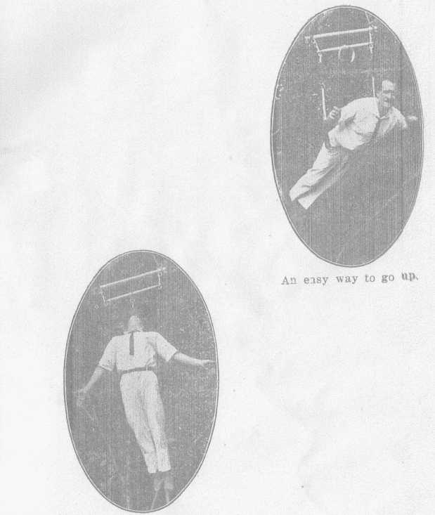
It’s all right, if he keeps his mouth shut.

in the world.
’ ’
“Airplanes simply aren’t in it,” the Professor asserted as with supple strength he finished folding his 'chute beside his little cottage by the lake. "The first year or so after they got to be successful they drew better than balloon-acts, but not for long. To-day, the crowd prefers balloons and ’chutes, hands down. I don’t care what ’plane act is put on, a balloon and ’chute-jump will always stop the show—always get the public. It’s one of oldest acts in the show-game, and still today the greatest outdoor drawing-card in existence.
“I’m simply stuck on jumping,” Bonette asserted his love of the game, despite the months of excruciating pain he has endured in order to thrill the world. “And," added this man of almost superhuman nerve and daring, "I'm very jealous of my job, you bet! It’s certainly grand sport. There’s not another thing in the world I’d rather do. Good money in it, too. A first-class jumper can make $100 a day, when he’s working. Often clean up anywhere from $400 to $550 a week.
“I love the excitement of it. As for the danger-- shucks! I don’t mind it any more than I do getting into my car and driving down to Bradford Village. There’s nothing to it, really. I’ve made more than two hundred jumps a year, many a time. More than four thousand, in all. Hope to make four thousand more, if nothing happens. And nothing can happen till it’s time for me to go —so there you are!
“A great life, now I’m telling you!” he concluded, with his golden, contagious smile. A fine, athletic figure of a man he made, standing there in the New Hampshire sun-

shine, erect and muscular; a man whose fifty-four years weigh lightly, and whose nerve is steel. “Jolly good fun, I call it! Yes, sir, if I had my life to live once more, I’d live it just the same as now. I’d still be a balloon-jumper, that’s what I would. I’d do the whole thing from start to finish—do the whole thing over again. That’s all I’ve got to say, and that’s enough!”

